INS3121
January 9th, 2019

Group 6: Assoc. Prof. Pelin Özener
Group 7: Asst. Prof. Dr. Nejat N. Çetinkaya

SOIL MECHANICS
FINAL EXAM
Q.1 | Q.2 | Q.3 | Q.4 | Q.5 | TOTAL
Name and Surname:
Number:
Group:

- a) Mark the correct answers for the following questions.

- Which of the following can exceed %100?
- Degree of Saturation (S) b) water content (w) c) Porosity (n) d) Relative density (D_{r})
- Which of the following term is not used to describe with fine-grained soils?
- Activity b) Plasticity c) Relative density d) Liquidity index
- Which of the following sieve sizes are used to separate gravel and fine-grained soils?
a) 4 - 40 b) 4-200 c) 40-100 d) 40-200
- Which one of the soil can be used as a subgrade material in a highway construction?
a) CH b) OL c) MH d) SW

- Plot the typical compaction curves obtained from standard proctor test and modified proctor test and show the compaction parameters obtained from these tests.
- Briefly describe the differences between consolidation and compaction.
- What are the parameters effecting on the shear strength of the sand soils? Explain briefly.

- A flow net under a sheet pile resting on a permeable silty sand soil is given in the figure. A constant head permeability test was performed on a soil sample recovered from silty sand soil with a height of 10 cm and a diameter of 5 cm. A constant head of 20 cm is kept during the test and a volume of 600 cm³ of water was collected over a time of 5 minutes. Based on this information;
k= (Q*L)/(t*A*Δh)
- Determine the permeability coefficient (k) of the silty sand soil.
- Calculate the seepage loss under sheet pile per unit width.
- Calculate the total head, elevation head, pressure head and pore pressure at point A with considering reference level is left side.
- Determine whether there is a quick sand condition at the point B or not.
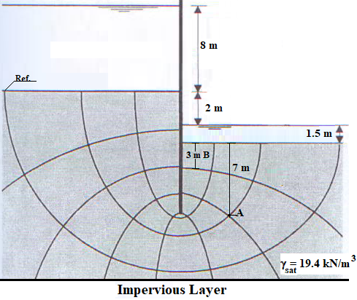

- A water tank will be constructed with a 10 m diameter on the soil profile given below. In order to find the amount of settlement, a soil sample was recovered from in the middle of the clay layer and a consolidation test has been performed with initial water content (w) = 24%. If the pressure transmitted from tank to ground surface is equal to 150 kPa;
- Calculate the consolidation settlements for the center and the corner of the tank and find the differential settlement. Determine the stress increases with Boussinesq method. (OCR= Over consolidation ratio= σ׳_{p}/σ׳_{v0}).
- If 20 mm thick soil specimen requires 42 minutes to complete 90% of consolidation in the laboratory how long will it take for the clay layer in the field complete 50% of consolidation. (U=90% Tv=0.848, U=50% Tv=0.197)
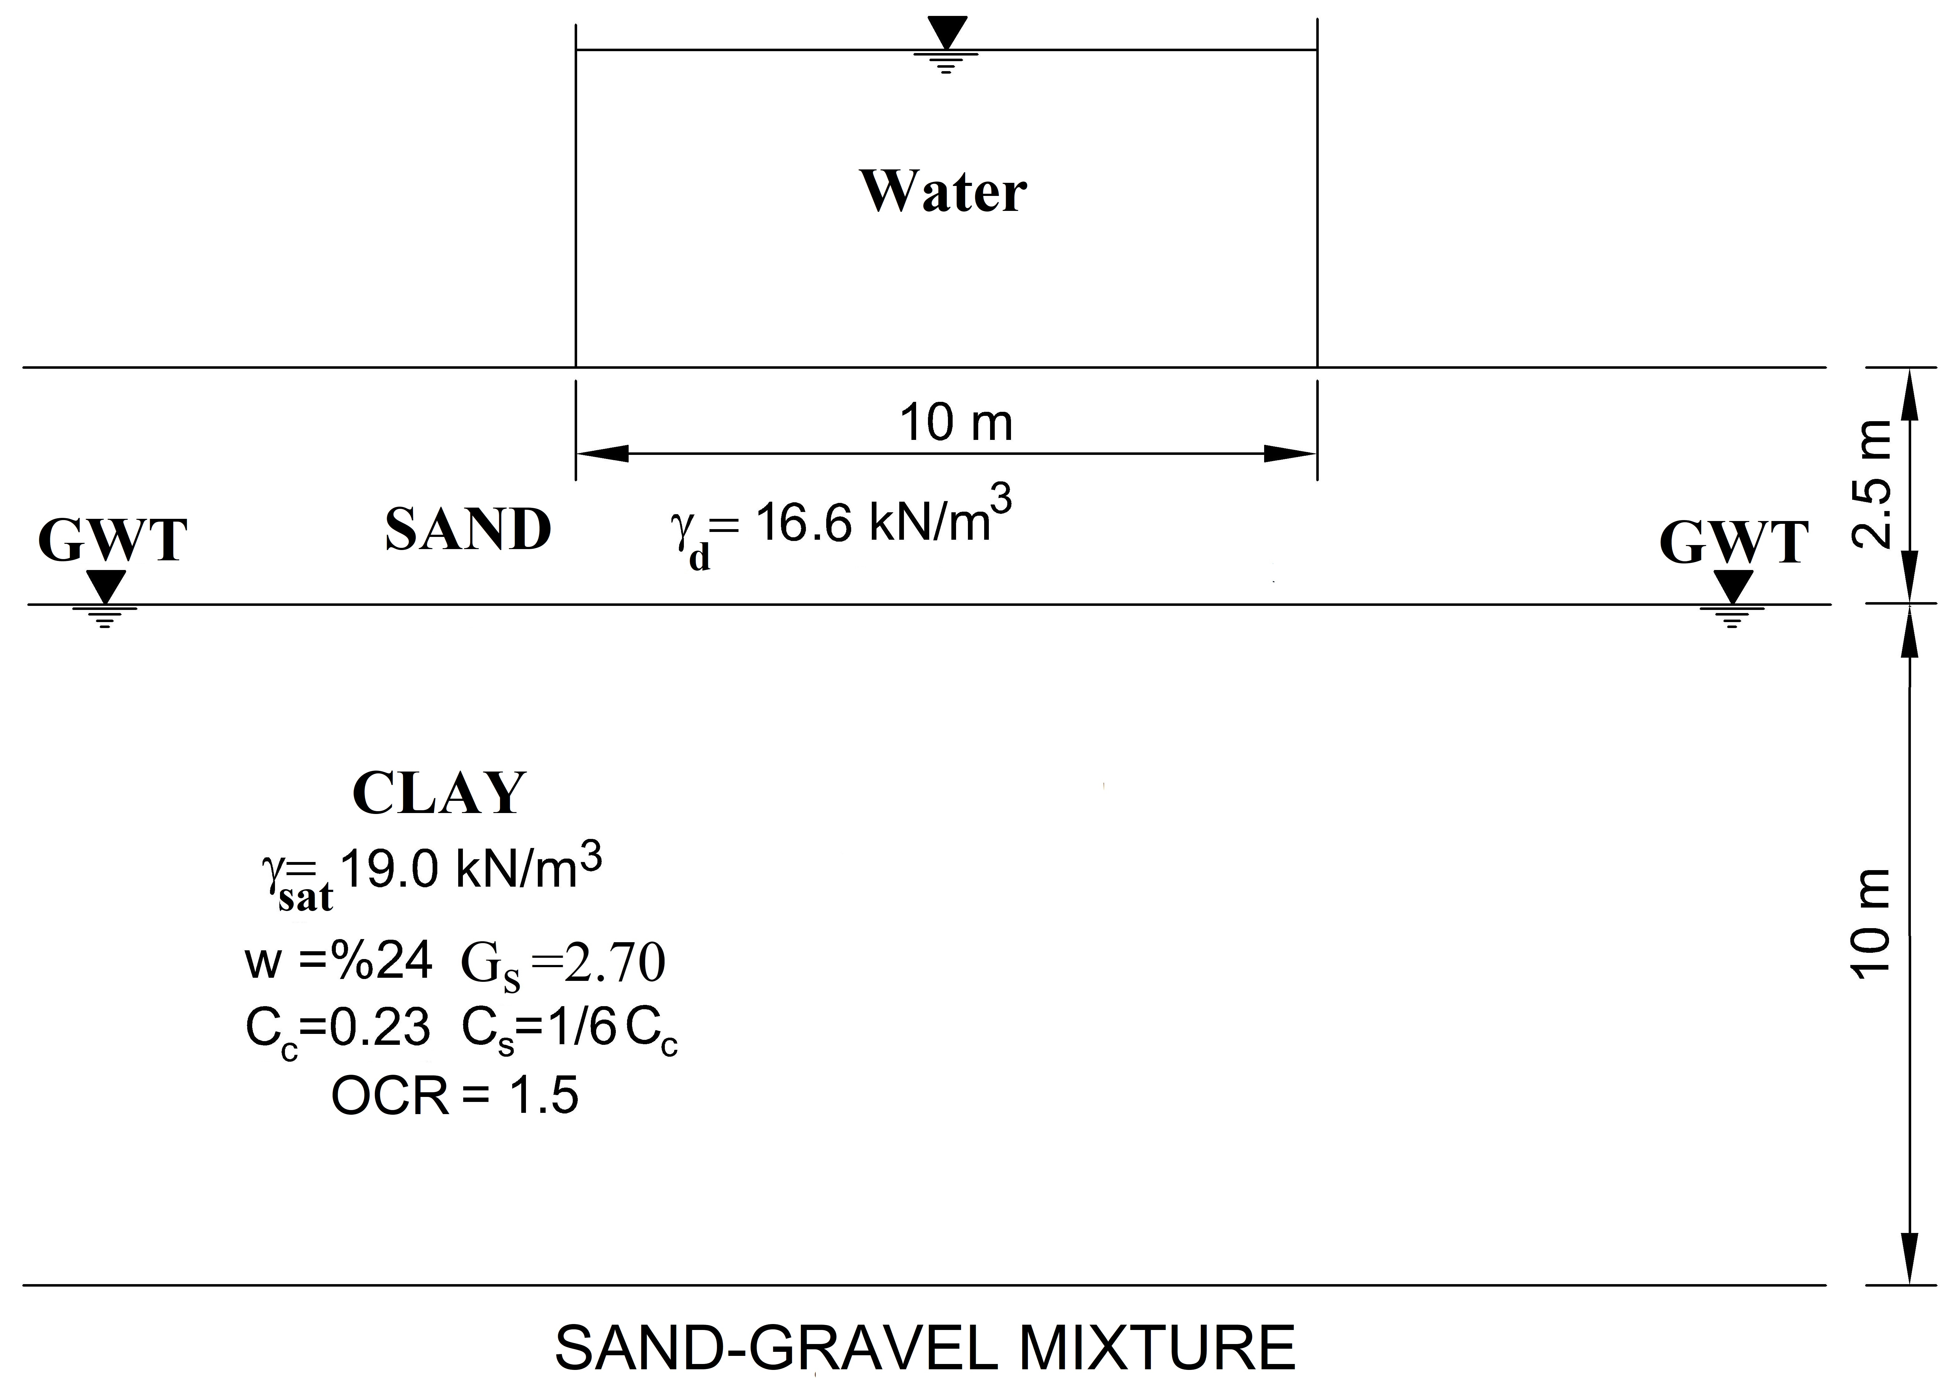

- A series of laboratory tests was conducted on a saturated normally consolidated clay and sand samples and results given below.
- Compute the effective and total shear strength parameters of the sand soil according to the result obtained from the direct shear test.
- Compute the effective and total shear strength parameters of the clay soil according to the result obtained from the CU test and plot the Mohr Circle and failure envelope.
- Compute the effective shear strengths of the soils at point A and B.
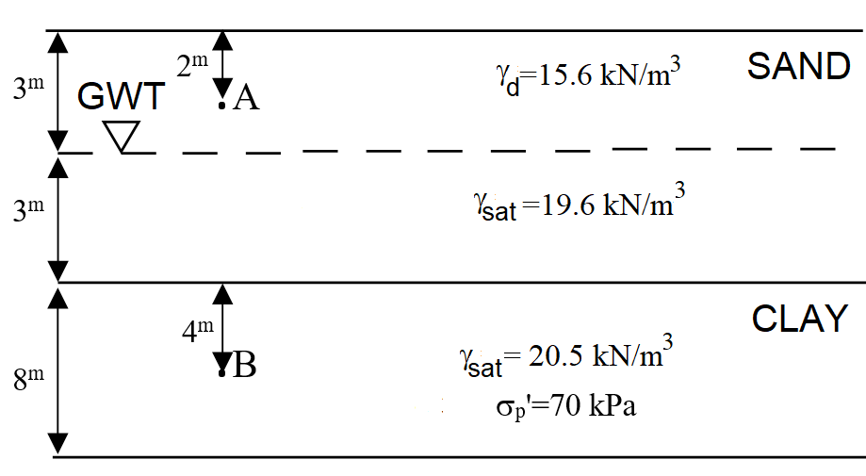
Direct Shear Test Results
Test No | 1 | 2 | 3
Vertical Stress (kPa) | 25 | 50 | 100
Maximum Horizontal Stress (kPa) | 17.5 | 34 | 69

CU Test Results
Cell Pressure (kPa) | 200
Deviatoric Stress (kPa) | 180
Pore Pressure (kPa) | 115

- A compaction test was performed on the soil samples which were recovered from the silty clay soil in borrow area and obtained results given in below figure. A volume of 0.15 m³ hole was excavated in the borrow area and moist weight and dry weight of the soil sample were found to be 1.95 kN and 1.77 kN, respectively.
  - Calculate how much excavated soil is necessary to construct a compacted fill of 7000 m³ assuming relative compaction of 100% (Specific unit weight of the soil is G_{s}=2.72).
  - If there has been a 25% loss of water during transportation from borrow area, determine if there is a need of addition of water during the construction of the fill and calculate volume of the water in the fill.

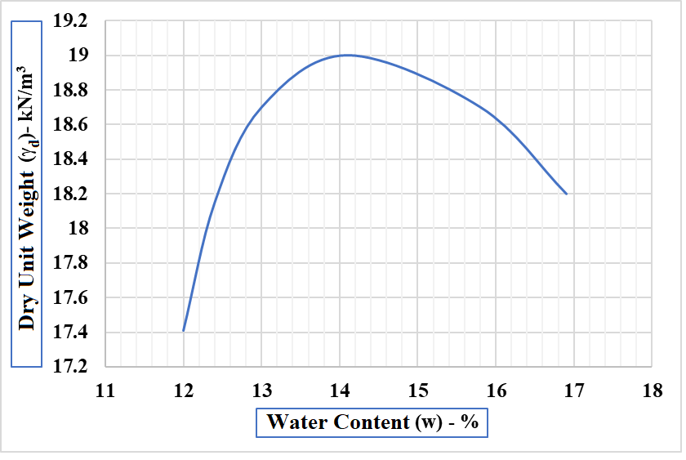

Time is 100 minutes. Good Luck…

